How to Use My NCBI and My Bibliography to Manage

NIH Public Access Compliance (Prepared by the NIEHS Library)

From www.PubMed.gov, sign into My NCBI Account. Use your eRA Commons login if you have one, or create a new account.

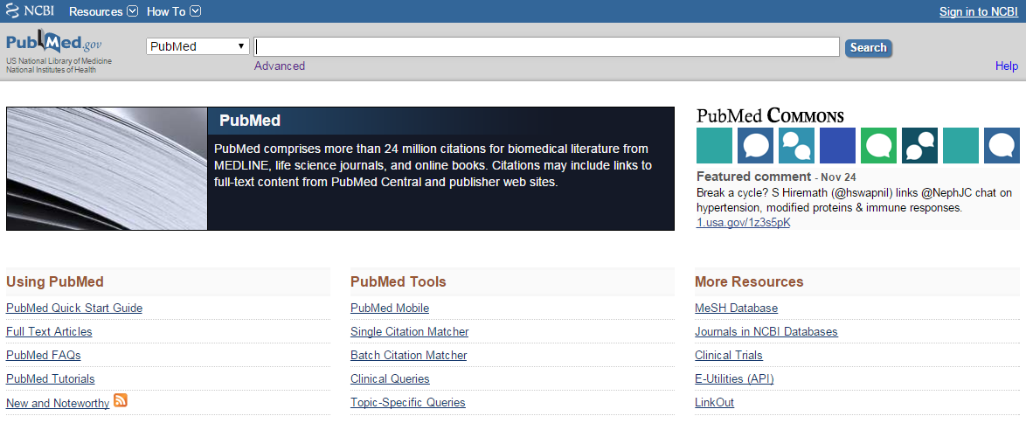

Once you have signed in to MyNCBI, return to the PubMed search screen and go to advanced search.

You will search PubMed to locate your articles and add them to My Bibliography, which is part of My NCBI.

To search by grant number, change the drop down search field to Grant Number and enter the grant number in the format shown below. You can also search by Author Name by selecting the Author search field.

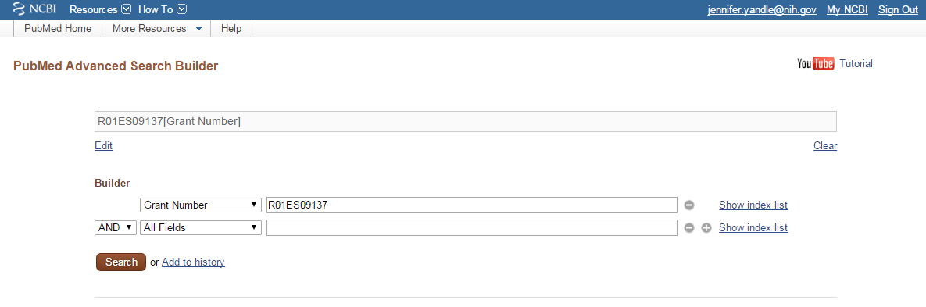

Once you have searched by grant number or author name, send your citations to your bibliography using the Send to feature. Select the My Bibliography tool and click Add to My Bibliography. It will ask you to save the items, just click to save.

Return to My NCBI via the link in the upper right hand corner. Then, under My Bibliography click on Manage my Bibliography.

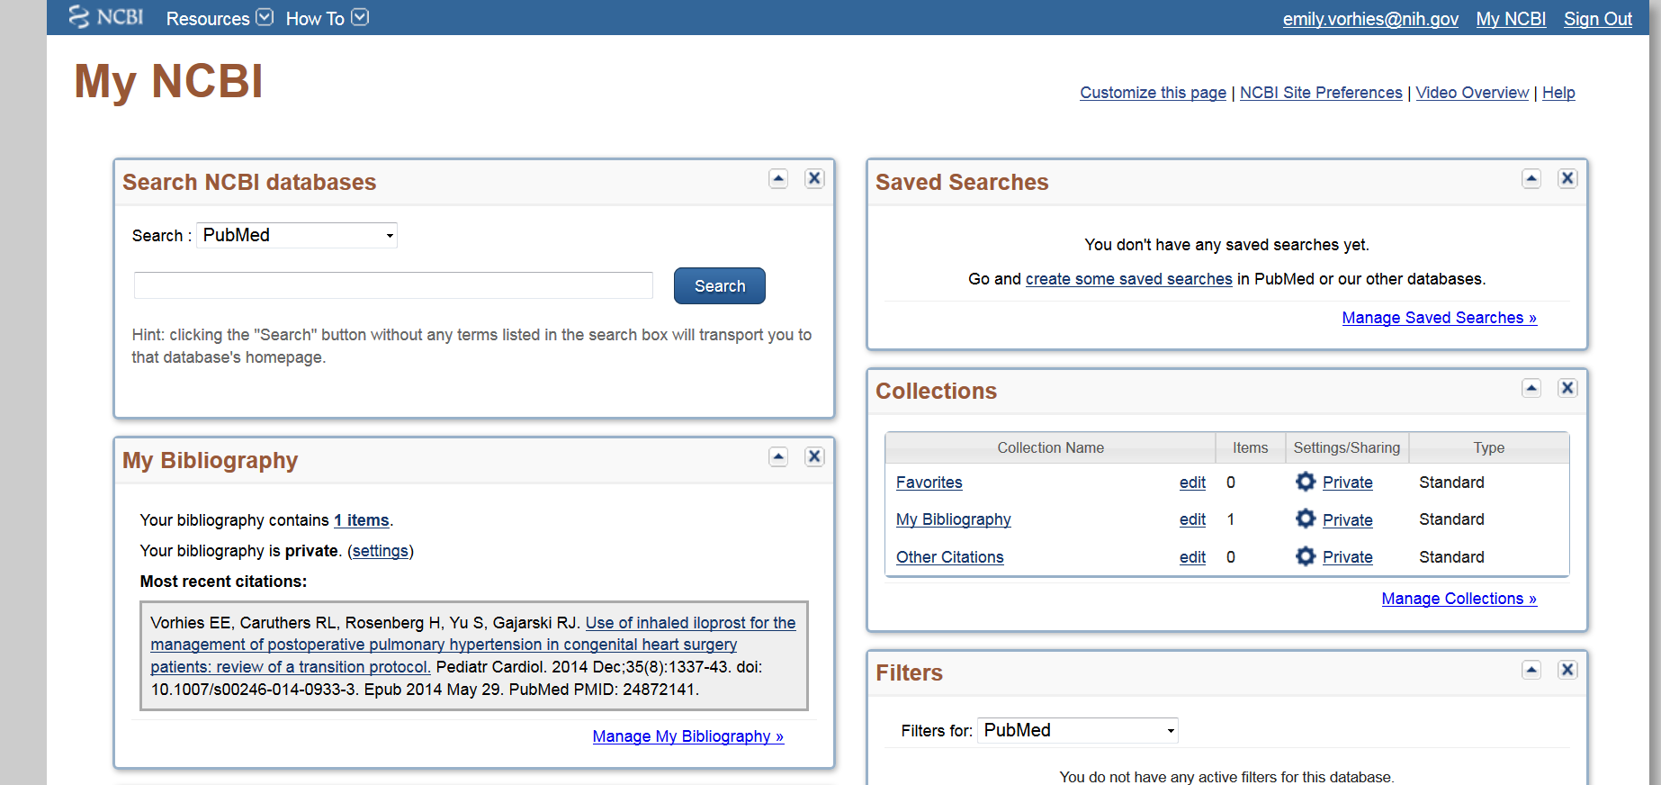

From the “Display Settings” drop-down menu select “Award” view, and click the Apply button.
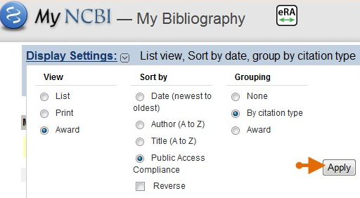
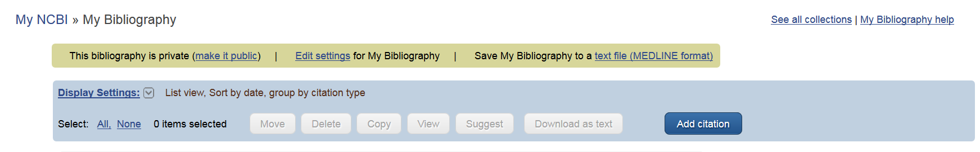

Each citation will have a visual cue that indicates compliance status:

On the resulting screen, each citation is marked with visual cues 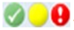 that indicate the peer review article compliance status.

Journal articles that are compliant with the NIH Public Access Policy are marked with a green dot and have the PubMed Central citation ID (PMCID) number listed.

In the below example, an NIH award ID is also associated with the citation.
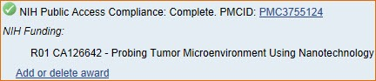

Articles newly submitted to the NIH Manuscript Submission system are considered in process and are marked with a yellow dot. Note that the article has been assigned an NIHMS ID number.
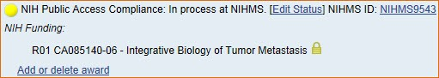

A red dot indicates that the article is non-compliant. The compliance process can be started by clicking the red dot or “Edit Status.” NIH funding information can be added to this citation by clicking “Add award.”

A question mark indicates that compliance with the NIH Public Access Policy cannot be determined without additional information. Click "Edit Status" to enter supporting information for the citation.
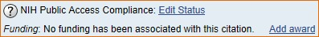

Need more help?
- Contact Erin Knight at the NIEHS Library (erin.knight2@nih.gov) or call 919-541-3426.
- Your home institution’s science or biomedical librarian should also be able to provide assistance.
- Find more information about checking your publications compliance status at My NCBI Help.

